|  |
| --- |
| **THE FOUNDATION FOR INCIDENT COMMAND**  **INITIAL INCIDENT COMMAND** |

**All areas** are considered to be of prime importance.

## AIM

The Foundation for Incident Command is to allow all Fire and Rescue personnel to provide the detail required for assertive, effective and safe incident command to be practiced and applied.

## OBJECTIVES

This training note along with the technical session covering this subject and participation in practical exercises will enable Watch Managers / Crew Managers to:

* Understand the level of competence an incident commander requires for effective command skills.
* Understand how to use the Incident command System with regard to Organisation at an incident.
* Explain the Safety Management required at an operational incident.

## Introduction

The Foundation for Incident command is designed to complement and support the National Operational Guidance for Incident command which is intended to assist policy writers in fire and rescue services in producing their local policies or guidance for incident command.

The Incident Command System provides the incident commander with a clear framework to structure, organise and manage an incident. It can be adapted to all sizes and types of incident and will help them deploy and use resources in an efficient and safe way. The incident command system allows the incident commander to use health and safety arrangements, including standard operating procedures, tailored to the characteristics of an emergency. This helps the incident commander to achieve appropriate balance between the benefit of undertaking planned actions and the risks associated with them.

Operational response is hazardous and firefighters respond to thousands of incidents each year. Some incidents may need only simple actions and procedures to deal with them effectively and safely as risks are low. Others are more challenging and may quickly increase in size, complexity and duration.

**3 Functional areas of the Incident Command System**

The Incident Command System is recognised as a ‘national safe and effective system for managing operations. It presents the key elements of the incident Command in 3 functional areas.

* **Command Skills**
* **Organisation at an incident**
* **Safety Management**

**Command Skills** – Command skills are the cognitive and interpersonal qualities critical for **assertive, effective and safe incident command**. To apply them, incident commanders should be able to understand the situation as it unfolds.

They should be able to:

1. Identify and priorities problems and develop a plan to resolve the incident.
2. Communicate this plan to others.
3. Co-ordinate and control activity in line with their plan.
4. Display the leadership needed to resolve the incident and operate effectively under the pressures of an incident.

**Organisation at an Incident** – Incident Commanders must be sufficiently trained, capable and knowledgeable to be able to effectively and safely organise resources to obtain the best resolution to an incident. It is the responsibility of all personnel, who may attend or are involved with an incident, to ensure that they are familiar with the requirements of the incident command system and that they can operate safely and effectively within it. This applies to those who will perform a command role and equally to those who will be operating under the command of others, including fire control.

**Safety Management** -The fire and rescue service may work in adverse and dangerous environments involving significant risks. The priority for an incident commander is the safety of the public, people under their control and anyone affected by their actions.

The health, safety and Welfare Framework for the Operational environment contains detailed strategic guidance on the planning and delivery health and safety policies relating to operational activity.

Operational personnel can remain as safe as possible if incident commanders:

* Identify hazards and risks
* Communicate the identified hazards and risks
* Adopted appropriate risk control measures
* Ensure people are using safe systems of work

**OPERATION DISCREATION**

Incident Commander may occasionally be presented with a situation that is extremely unusual and not reasonably foreseeable. In this circumstance they may have to make decisions using their professional judgment.

**Operational discretion relates to rare or exceptional circumstances where strictly following an operational procedure would be a barrier to resolving an incident, or where there is no procedure that adequately deals with the incident.**

**Commanders need to be sufficiently aware of procedures, the skills and qualities of crew members and the capability of resources available.**

Outcomes which justify applying operational discretion include:

* Saving human life
* Taking decisive action to prevent an incident escalating
* Incidents where taking no action may lead others to put themselves in danger.

The overarching principle should be that in the opinion of the incident commander the benefit of taking unusual, unorthodox or innovative action justifies the risk. See Decision control process.

Any decision to apply operational discretion should be the minimum necessary and only until the objective is achieved.

To support the post-incident learning process, fire and rescue services should have procedures for incident commanders to record the reasons that support their decision. The extent of the record should match the severity and/or complexity of the incident.

On occasion, crew members and/or members of the public might apply pressure on an incident commander to act. An incident commander can apply operational discretion; therefore it is unlikely that a crew member would intervene entirely of their own volition without putting colleagues or members of the public at additional serious risk.

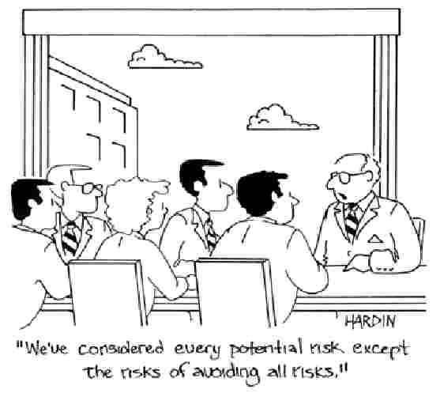

|  |
| --- |
| **COMMAND SKILLS** |

Command skills are the cognitive and interpersonal qualities critical for **assertive, effective and safe incident command**. To apply them, incident commanders should be able to understand the situation as it unfolds. They should be able to:

* Identify and prioritise problems and develop a plan to resolve the incident
* Communicate this plan to others
* Co-ordinate and control activity in line with their plan
* Display the leadership needed to resolve the incident and operate effectively under the pressures of an incident

As well as having technical knowledge, an incident commander should possess command skills to underpin their judgements, decisions and behaviours.

Command skills are complex in nature and can be developed with understanding and practice.

Leadership; F&RS personnel, members of the public, other blue light services, expect an incident commander to be calm, confident, decisive and professional. People who are led well at an incident will invariably be willing, motivated and committed.

This can be described as Command Presence and Incident Commanders should always consider the impression they are creating.

## SITUATIONAL AWARENESS

## Situational awareness is a person's perception and understanding of the situation they face. It includes their anticipation of what the situation may become, including the impact of their actions. For an incident commander, it is their perspective of the scene of operations.

## 

## This situational awareness, or mental picture of the incident, is the foundation for the incident commander to formulate a plan of action. On the basis of this understanding, the commander will assess risk and make decisions, identify and prioritise objectives and develop an incident plan. The commander will also look ahead and consider how an incident will develop and also predict the consequences of actions.

## Maintaining good situational awareness of the incident is a critical skill. Incident commanders need to have the ability to build an accurate mental picture of the situation. They need to be able to do this in challenging, dynamically changing and high-pressure circumstances, sometimes with incomplete or inaccurate information.

## Person’s mental picture of an incident is like a jigsaw, made up of many sources of information interpreted as a single view. An example of this is shown below.

## http://www.ukfrs.com/Lists/Photos/071315_0815_Thefoundati1.pngSome pieces of this jigsaw come from direct exposure, for example, to events that can be seen or directly experienced at the incident. However, an incident commander may not have all of the information available that they need to form a full and accurate picture.

## Other pieces of the jigsaw come from memories of similar events, assumptions or communications with others. These elements combine with the information that is directly available to create a mental picture. Therefore, it is important for incident commanders to constantly monitor their situational awareness, and verify the accuracy of any assumptions that might underpin their understanding of the situation.

## A person's mental picture of an incident is made up of many sources of information. They are interpreted into a coherent picture in a way that makes sense to them in the current circumstances of the incident. It is important to consider the relationship between the information that was reasonably available and how the conditions have affected a commander's ability to process it.

## The working conditions at an incident may affect their ability to process information. For instance, the amount of information they need to process, the tasks they are involved with and the amount of stress they are feeling all take up part of a commander's capacity to process information. Evaluations of operational decisions, whether post incident or in a training environment, should take this relationship into account.

## Good situational awareness is essential as it underpins operational decision making. Decision makers, both incident commanders and firefighters alike, make decisions based on their perception of the *situation* and their perception of the problem. For decision making to be effective, it is necessary for the incident commander to put in place the means to continuously monitor the environment to detect changes, and to ensure their understanding of the situation remains accurate, for example, an appropriate command structure and communication network.

## STAGES OF SITUATIONAL AWARENESS

## There are three stages of situational awareness:

## Information gathering

## The incident commander will gather information from a variety of sources to gain accurate situational awareness. They use it to develop their mental picture, monitor changes and track progress. The information will relate to the incident as a whole, the task itself, available resources, and hazards. Incident commanders should be aware of potential sources of information such as:

## Communication: with team, other agencies, specialists, people at the scene, fire control

## Surveying the scene: information from what they can see, hear, smell and touch

## Site specific risk information: sources from pre-planning, or available at the scene

## Incident commanders also need to understand why they may fail to gather information correctly such as:

## Information is incomplete or unavailable

## Distractions causing information to be missed

## They fix their attention on an element of the situation, so they miss other information (tunnel vision)

## New information does not fit with their current view of the situation so they ignore it (confirmation bias)

## They fail to scan or re-scan the incident scene to gather information

## Information is difficult to detect

## Misperception or misunderstanding information

## Poor communication from others

## Understanding information

## After a commander gathers information, they will process it and extract the meaning. This helps them form an understanding of the situation. They will integrate this information with knowledge and memories, which may include:

## 

## Experience of the same or similar premises or locations

## Experience of the same or similar situations

## Assumptions

## Expectations

## Mental models:

## Knowledge structures formed from previous learning. In this context, it is a file of information stored in memory that represents a combination of cues and their meaning. For example, an incident commander may have a mental model of how to resolve a type of incident, or how to operate a piece of equipment.

## Combinations of cues or pieces of information may activate a previously formed mental model. When a particular mental model activates, it maps out what they expect to happen and typical actions or responses.

## Activating a mental model may also lead the incident commander to direct attention to information relevant to the situation. This has some benefits. It saves time and frees up mental capacity to process information. However, it can also lead to neglecting other pieces of information that might prove to be important. It may also lead to confirmation bias.

## Experience, context and assumptions can supplement or distort an incident commander's interpretation of the scene.

## Anticipation

## Incident commanders should be aware that they use their understanding of the situation to anticipate what is likely to happen next. For example, how the situation might develop and the consequences of their actions. This means it is vital that their interpretation reflects the actual situation as accurately as possible.

## This is the highest level of situational awareness. It allows the incident commander to effectively plan their operational activities by understanding how the situation is likely to develop and predicting what impact a particular intervention might have. This helps the planning process ensure the right action is taken.

**EFFECTIVE SITUATIONAL AWARENESS**

**Clear briefing**

Clear, accurate and timely briefings to and from the incident commander will help to ensure people share up-to-date information.

**Minimising distractions during critical tasks**

This may help to reduce demands on mental processing capacity. Effective organisation at an incident can assist with reducing distractions. Appropriate spans of control can reduce the likelihood of becoming overloaded with information by delegating responsibility for certain areas or tasks. Delegation allows the incident commander to maintain an overall view of the situation. Maintaining good lines of communication is vital. They ensure people exchange accurate, relevant and timely information.

**Regular review**

Incident commanders should regularly compare their mental picture with cues and information from the current situation to ensure their situational awareness remains accurate to maintain accurate situational awareness and detect changes.

**Self-awareness of stress and fatigue**

The incident commander should be aware of the signs and symptoms of excessive stress. Stress and fatigue may impair situational awareness and they should take appropriate action to manage the impact on people. See Personal Resilience.

**FACTORS THAT AFFECT SITUATIONAL AWARENESS**

**Location of incident command point**

Its siting and the potential scale of incident scene may prevent visual cues from the incident being seen.

**Limitations of human perceptual systems**

Human perceptual and memory systems are not infallible. A strong focus on one part of the situation, or element of the environment, can lead to other sources of information being neglected or missed.

**Stress**

Anxiety and stress take up part of a person's mental processing capacity. They can distract attention from the situation. They can also reduce available capacity for focusing on and understanding information. Neglecting important information or not processing it properly may lead to an inaccurate mental picture of the situation.

**Fatigue**

Can reduce mental processing capacity. As with the effects of stress, this can reduce the capacity available for processing and making sense of information.

Information overload

Can be overwhelming. It can take up mental processing capacity, leaving less to focus on and understand the wider situation.

**Automatic actions**

A cue might automatically cause a certain response. Automatically responding to an element of the situation may not always fit with the required overall incident response. See Intuitive and Analytical decision making.

**Tunnel vision**

Under some circumstances attention may become unduly focused on some elements of the situation, rather than looking at the incident as a whole. This is known as tunnel vision.

**REACHING A DECISION**

Incident commanders need to have the ability to make sound decisions based on the elements that make up an incident, as well as having an accurate overall interpretation of the incident. This leads to effective, assertive and safe incident command.

Decisions are made throughout an incident and involve:

•Deciding what the problem is

•Assessing risk

•Identifying and prioritising objectives

•Deciding tactical priorities

•Develop a plan that gets from one position to another

There are a number of ways that incident commanders may reach these decisions. They can be broadly grouped into two main categories:

•Intuitive decision making

•Analytical decision making (AD)

**INTUITIVE DECISION MAKING**

These are rapid, reflexive processes that are experienced as relatively automatic. Some decisions can be very reflexive. Such intuitive processes are fast and are usually invoked without consciously thinking. They may be driven by cues and clues that can automatically and directly trigger a decision or response.

Commanders can react to elements of the situation, such as the cues and clues that act as triggers. This might be via Conditioned Processes (CP) or a Recognition Primed Decision (RPD) approach. A conditioned connection is very automatic, so does not involve explicit planning. This means that the rationale is not considered at the time, making it difficult to articulate the reasons that action is taken.

Recognition primed decision making is a similarly reflexive process whereby elements of the situation may prompt the commander to recognise, remember and select the responses they made to similar situations in the past. Because this process is also fast it feels like an automatic response. There is little conscious deliberation.

Recognition primed decision-making processes may be useful for decision makers operating in a relatively familiar and routine situation. Such processes are less likely to be useful at more novel or unusual incidents where there may be less experience to draw on.

Incident commanders should also be aware that because recognition primed decision making involves matching cues from the current situation to one that the decision maker recognises, it might encourage the decision maker to look for evidence to support their interpretation of the situation. The actual situation may not reflect the interpreted situation. An incident commander should be aware of these possibilities and should consider using decision controls before they implement a decision.

**ANALYTICAL DECISION MAKING**

These more reflective processes involve a greater degree of conscious mental effort. Here, the situation is analysed. The commander may draw on their knowledge, memories and experience that relates to the situation or problems faced. They will then consider what to do.

They might:

* Use a rule-based process, for example, a standard operating procedure
* Compare and evaluate possible options
* Create a completely new solution to an unfamiliar problem

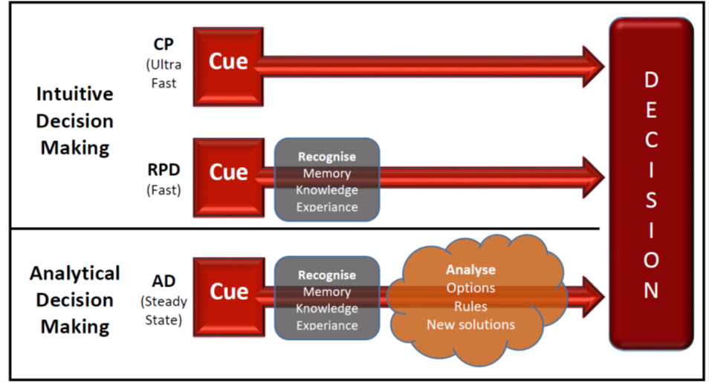

These processes apply to all decision makers on the incident ground. They have equal importance for a firefighter wearing breathing apparatus who chooses what to do next, to an incident commander developing their plan. Although the method of decision making is not always a conscious choice, it is important for commanders to be aware of the processes that might drive their decision making. They should be aware of the potential decision traps.

**DECISION MAKING IN THE OPERATIONAL CONTEXT**

Fire and rescue services need incident commanders to operate in a complex decision-making environment. This environment is uncertain, with competing demands and problems that can affect many aspects of the scene.

To resolve the incident, incident commanders should:

* Understand their starting position
* Know their desired end position
* Develop a plan that gets from one position to the other

To do this well, all decision makers should understand the factors that are likely to influence the way they make decisions. They should be aware of the potential decision traps.

Factors in the operational context, such as high-pressure situations, may affect the way people reach a decision. In particular, analytical decision processes that are relatively reflective need more time and mental effort than other processes. It takes time to evaluate and select a course of action. Analytical processes can be more susceptible to the effects of excessive pressures and they reduce the capacity for mental processing.

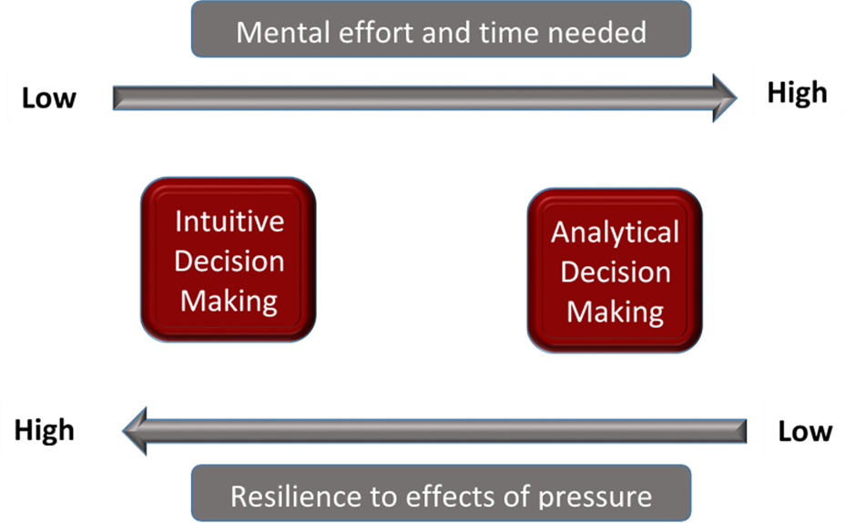

**DECISION TRAPS**

A decision trap can be described as a thought process that can lead to a situation going wrong.

There are a number of decision traps that may make decisions in the operational context less effective. Decision makers should be aware of these and should apply decision controls to guard against unintended consequences. See Decision controls.

Examples of decision traps include:

**Decision does not fit with the objectives, tactical priorities or incident plan**

One of the pitfalls of some of the more reflexive, intuitive process is that sometimes the planning processes are bypassed. This means that an action might be intuitively or automatically implemented without considering the actual incident objective, goal or tactical plan. There may be times when the response they select might not fit with achieving the wider goal for an incident.

**Decision made on the basis of part of the situation (such as a cue or a goal) whilst not taking account of the overall picture**

A great deal of decision making occurs on the incident ground, from crew members to those with commanding roles. The operational context is complex and there may be a requirement to make decisions on a wide variety of issues. There are times when decisions are made that relate to very narrow or specific elements of the situation, such as a particular cue or goal. However, there is a danger of unintended consequences if decisions are made on these elements in isolation, without considering the impact on other activities, objectives or the incident as a whole.

**Decision is based on the wrong interpretation**

Poor situational awareness can lead to an interpretation of the incident that does not match the reality of the situation. A decision then made on the wrong interpretation may lead to unintended consequences.

**Decision aversion**

Decision aversion is a failure to make a decision. High risk, high pressure and rapid change can create uncertainty about what to do. Decision makers may also be uncertain about possible alternatives and consequences. This may be challenging if the stakes are high and they have to choose what to do. For example, a commander must make a timely decision to determine if they are operating in either offensive or defensive mode, as there is no default tactical mode. Excessively focusing on accountability and scrutiny can make decision aversion worse. They may develop an excessive focus on potential negative consequences rather than the tactical concerns of the incident. Sometimes this may show as risk-aversion with a focus on self-protection rather than making an operational decision. They may not make a decision or seek to refer decisions to another decision maker. Fire and rescue services should be aware that their organisational culture may affect decision aversion.

**Failure to actively monitor and review**

Decision makers may not be aware of the progress of an incident. If they fail to monitor and review the impact of their decisions, it can affect their situational awareness. If they are not aware of progress it's difficult to make good predictions about what is happening. It also makes it harder to understand how the situation might develop.

**DECISION CONTROL PROCESS**

The Decision Control Process (DCP) supports decision making at an incident. This aims to take account of the natural decision processes a person might employ in an operational context. It seeks to support decision makers in a practical way to avoid unintended consequences arising from decision traps.

The DCP is scalable. It can be applied to basic decisions made on the incident ground for a task or problem. It can also scale up for use in planning the resolution of an entire incident. It complements the JESIP Joint Decision Model for multi-agency making, particularly for the element of assessing risk and developing a working strategy.

**Situation**:

Commanders base their decisions on the way they interpret a situation. Good situational awareness is key to understanding the situation in a coherent way. It helps to predict likely developments. By assessing the situation, a decision maker can understand the current characteristics and details of an incident and consider the desired end state.

Decision makers should continually be assessing the situation to support an accurate awareness. They should gather relevant information whilst making the best use of the time available.

**Plan**

When forming a plan, the commander should understand the current situation and the desired outcome. From this they can identify their objectives and develop an incident plan.

**Decision controls**

Decision controls are designed to help guard against decision traps that might occur as a result of the type of decision process people naturally adopt in a situation. Before moving to the action phase, decision makers should use decision controls. They can do this as a fast, mental check or use them as part of a briefing.

**Decision controls are a rapid mental check that asks:**

Why am I doing this? What goals does this link to? What is my rationale?

What do I think will happen? Anticipate the likely outcome of the action, in particular the impact on the objective and other activities. How will the incident change as a result of this action, what cues do I expect to see?

Is the benefit proportional to the risk? Consider whether the benefit of our actions justify the risks being accepted.

**Action**

This phase involves implementing the decisions that have been made. Where feasible, decision controls should be applied before this phase, or as soon as possible afterwards. This applies whether decision makers get to action from planning or directly from situation assessment.

**DECISION CONTROL PROCESS MODEL**

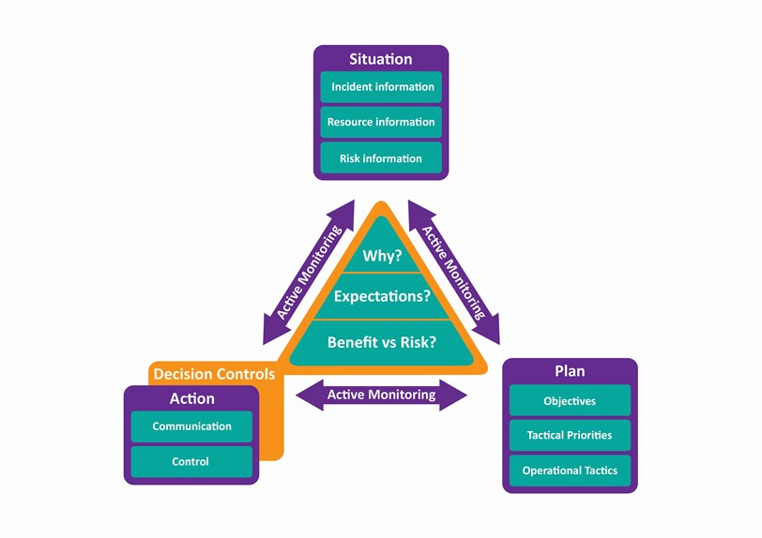

**PERSONAL RESILIANCE**

There are two types of stress that an individual may experience. These will adversely affect an incident commander’s behaviour and distract them from commanding the incident. This in turn jeopardise the safety of operations.

**Chronic stress**

A response to persistent, poorly managed pressures usually over a prolonged period of time. Such stress may lead to serious health conditions such as anxiety, insomnia and high blood pressure.

**Acute stress**

A reaction to sudden, unexpected events such as those that may be experienced when working in a dynamic, high-risk environment when commanding an incident. Such stress will involve significant physiological psychological effects akin to the fight, flight or freeze responses observed in animals.

**CAUSES OF STRESS**

People differ in the way stress can affect them. Some effects can be subtle changes from normal behaviour. There is no definitive list of behavioural indicators and the effects can differ between individuals.

There are a number of significant factors associated with acute stress that may affect the incident commander and members of their teams. Even one team member who is affected in a negative way can be enough to affect the way a team function. Incident commanders should be aware of the symptoms that suggest stress and pressure are damaging how the team works together.

|  |  |
| --- | --- |
| **Causes of stress and pressure** | **Symptoms** |
| **Incident environment** | Pressure from the incident ground may include physical aspects, such as noise, heat, darkness and adverse weather. It may also include distressing scenes and moral pressure to take actions |
| **Uncertainty about the situation** | If an incident commander does not understand the nature of the incident, the hazards and risk associated with it, they may not be able to accurately predict the outcomes of their operational tactics. Consequently, the correct decisions and actions may not immediately be known. |
| **Workload management** | A high workload that is not appropriately managed can lead to a number of issues that undermine assertive, effective and safe incident command. For example; critical information may be over looked, or the incident commander may become overwhelmed. This may occur when spans of control become too broad. |
| **Time pressure** | The need to take risk critical actions within a short time frame versus the resources and ability to undertake those actions. This may be because life critical rescues need to be carried out, or rapid changing situations |
| **Fatigue** | Physical and psychological fatigue can cause stress. |
| **Performance anxiety** | Fear that is triggered when required to undertake the role of incident commander, or the anticipation of undertaking the role |
| **New or unusual situations** | An unknown situation where the incident commander has no experience or recognised procedures to draw on to decide what actions are appropriate. |
| **Expectations not met** | An incident that alters in an unexpected way, or where indicators of progress or incident type do not fit with current situation awareness may violate expectations. Also system, procedural or equipment failures, or human error may result in a plan not being implemented in accordance with expectations. |
| **Missing critical information** | Level of situational awareness is low, therefore, the corresponding uncertainty makes it more difficult to anticipate what might happen next, especially in relation to risk critical actions. |
| **Multiple goals** | Complex incidents may generate critical situations that require more than one goal to be addressed resulting in conflicts between objectives, including those of other agencies. This may lead to indecision and hesitation about prioritisation and the actions to be taken. |
| **Unsuccessful implementation of a plan** | Expectations associated with the plan about the sequence of events are not met, which introduces uncertainty about the situation. |

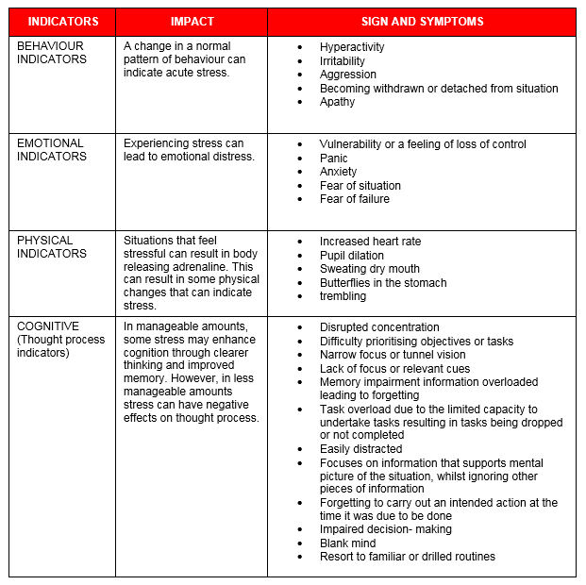

## LINES OF COMMUNICATION AVAILABLE

The Incident command System reduces spans of control to a manageable level and improves control and communications.

Understanding the ‘span of control’ concept is important when managing a large amount of activity and information.

There are many different types of forms of communication which are used at incidents.

**Verbal** – Most communication at incidents is verbal, either directly or through radio communications. Incident commanders need to be aware that verbal communication is important when building understanding for teams to complete tasks.

**Non-verbal –** People are constantly communicating, even when not using words. Non-verbal communication can be used to complement or reinforce verbal communications and is also a major signal of emotional state. E.g.

* Facial expressions and eye movement
* Body movements and gestures
* Voice characteristics and qualities

**Written** – When written information is captured on the incident ground, care should be taken to ensure it is accurate, clear and relevant. This may involve a variety of personnel from a command support team member, to a loggist who will record the decisions and conversations of an incident commander.

**Electronic** - Mobile data terminals, computer-based command support systems, digital cameras and mobile telephone devices may provide an incident commander with visual as well as written information about an incident, e.g. via a helicopter downlink, risk database or social media websites.

**BARRIERS TO COMMUNICATIONS**

There are many barriers to communication, which may lead to misunderstandings that impact on the effectiveness and safety of incident operations. For example;

**Verbal**

* Remote from receiver
* Inappropriate language
* Language difference
* Inability to hear
* Noise
* Interference
* Distraction poor listening skills

**Non-verbal**

* Emotions
* Incongruent body language (to nature of message)
* Lack of body language (remote from communicator)
* Voice level
* Status
* Culture
* Stereotyping
* Discrimination

**Written**

* Language difference
* Poorly written script
* Spelling errors
* Punctuation errors
* Poorly formatted documents

**Electronic**

* Hardware failure
* Software failure
* Communications network failure
* Over reliance on electronic communication

**Methods used to have effective communication when briefing operational crews**

Effective communication is when information has been exchanged and is understood in the way it was intended.

**Is clear –** Avoid ambiguity by using commonly understood terms. This is especially important when working with other agencies. Remember that for other agencies some terms might have different meanings

**Is relevant and concise** – Keep communications to the point. This is essential during high pressure situations. Incorrect information can over load the receiver and the meaning can be lost; information should only be exchanged with relevant individuals.

**Is timely** – Communications should be made at an appropriate point in time. To avoid distractions from critical tasks consider how urgent the information is and the current task demands of the receiver.

**Is understood** – This prevents misunderstanding and difference in shared situation awareness.

**Question assumptions** – Both senders and receivers of information may have assumptions about information.

**Is assertive** – There is a clear benefit to bring assertive to clarify mean meaning and test assumptions. Both confidence and status can affect the ability to be assertive under pressure. It is important for an incident commander to be able to distinguish between being passive, assertive and aggressive.

**Encourage effective listening** – The environment at an incident can make it more difficult to communicate. Noise, adverse weather conditions and heightened levels of activity can be distracting and make listening difficult.

**Match words and behaviours** – People are constantly communicating, even when not using words. When verbal and non-verbal messages match, it helps people to make sense of the message. E.g. a calm approach reinforces a reassuring message.

**Briefing Dynamically**:

Good communication is the key to the plan being successful! Try to spread the word of the plan and where people fit into it. **All risks and cordons must be communicated**.

Remember: **S – SITUATION, R – RISK**, **P – PLAN**, **R – RESOURCE.**

**S – SITUATION,** what is the current situation now?

**R – RISK**, what are the current known risks?

**P – PLAN**, what is your plan to deal with risks and to drive the incident forward?

**R – RESOURCE**, what resources I have and what do I need to help drive the incident forward.

**SRPR** is deemed best method for briefing dynamically.

Structure your brief around SRPR, it helps to keep it to the point and covers all that a person needs to know about the incident and their role within it.

|  |
| --- |
| **ORGANISATION AT AN INCIDENT** |

**LEVELS OF COMMAND**

There are 3 levels of command and these levels are role related and titles may not reflect seniority of rank. Instead, they show the function carried out by that particular person or group.

**Operational**

* The operational commander will control and deploy the resources of their respective service within a functional or geographical area and implement direction provided by the tactical commander. As the incident progresses and more resources attend the scene, the level of supervision will increase in proportion.

**Tactical**

* The tactical commander will be located where they can maintain effective tactical command of the operation. Invariably the fire and rescuer service incident commander will be in attendance at the scene. They will either attend the tactical co-ordinating group (TCG) when in operation or nominate a liaison officer to attend.

**Strategic**

* The strategic commander in overall charge of each service is responsible for formulating the strategy for the incident. Each strategic commander has overall command of the resources of their own organisation but will delegate implementation decisions to their respective tactical level’s commanders. When strategic commanders, from respective agencies, meet they are known as a Strategic Co-ordinating Group (SCG) in England and Wales, Regional Resilience Partnership (RRP) in Scotland and Civil Contingencies Group (CCG) in Northern Ireland.

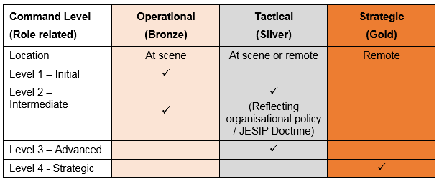

**Incident Commander**

The incident commander has overall responsibility on the incident ground. In order to resolve an incident assertively, effectively and safely they should;

* Command and control the incident
* Identify hazards and manage risk
* Assess resources requirements
* Determine an incident plan
* Co-ordinate and deploy available resources
* Evaluate progress against the plan

**Sector Commander**

A sector commander may be appointed to be in charge of a defined physical, geographical or functional area of operations. The role of the sector commander is to command resources within their sector. The sector commander will report to the incident commander or operations commander if in place. They will take responsibility for resources and the achievement of objectives within their sector. The sector commander will mainly focus on implementing the incident plan, effective command and control, resources deployment, firefighting tactics and rescues.

**Command Support**

Command support and its related support sectors are critical to resolving incidents. An incident commander cannot manage a complex and rapidly developing incident alone. Effective and structured support system that can vary with the size and demands of an incident need to be implemented. Command support should be used at all incidents to help the incident commander manage an incident. It should be put into place as soon as is practically possible.

|  |
| --- |
| **THE COMMAND TEAM** |

**The command team**

The command team includes the Incident Commander and any other personnel that are operating in a commanding role (e.g. Command Support, Operations Commander and Sector Commanders).

Fire and rescue services will have different approaches towards deciding which roles and functions form part of the command team. However the main aim is to enable clear communications and decision making between the Incident Commander and those performing operational tasks.

It is important to keep the span of control for tactical roles as narrow as possible. Do not give individuals so many aspects that they cannot give them enough attention. The Incident Command system provides a structure which maintains manageable spans of control.

The system provides for additional roles within the incident command structure. This reduces the burden on the incident commander. The command team concept can also be applied to Operations Command, Sector Command, and functional Command Support activities.

At all incidents a command support function should operate. This should be scalable depending on the complexity of the incident to assist an incident commander to manage reporting lines. It can ensure that critical information and advice reaches the right people on the incident ground, in a timely manner.

The specific arrangements vary with the circumstances of the situation and the stage of the incident. The command team approach offers an incident commander the means of managing complex situations. It creates a team of commanders working together who can function better than an individual.

An Incident Commander may be able to manage and oversee small incidents on their own. Once there are a number of crews present, the Incident Commander should consider appointing Sector Commanders to supervise the crews.

Once an incident has become more complex, with a number of sectors in use, the Incident Commander may choose to appoint an operations commander. This role will manage the sectors and reduce the span of control for the incident commander. If the number of sectors continues to grow, they may need to group the sectors under more than one Operations Commander. The system is able to scale up to any situation as needed.

Despite delegating responsibilities, the Incident Commander is responsible at all times for the overall incident management. They will focus on the command and control, the use of resources, incident planning and the co-ordination of the sector operations.

**Identification of command roles**

The command team includes officers who have a variety of roles. It is important to make sure they can be easily identified using a commonly understood method. This is particularly important at incidents that cross borders and other large incidents where officers who may not know each other work together.

The following are common methods of identification:

* Incident Commander: white and yellow tabard (or in Scotland, red and white quadrants)
* Sector Commander: yellow and red tabard
* Operations Commander: red tabard
* Command Support: red and white chequered tabard with yellow
* Tac advisor: red and white chequered tabard with the reference, for example, HVP, NILO
* Safety Officer: blue and yellow tabard
* BA Entry Control Operative: black and yellow chequered tabard
* Mass Decontamination Officer: green and purple tabard

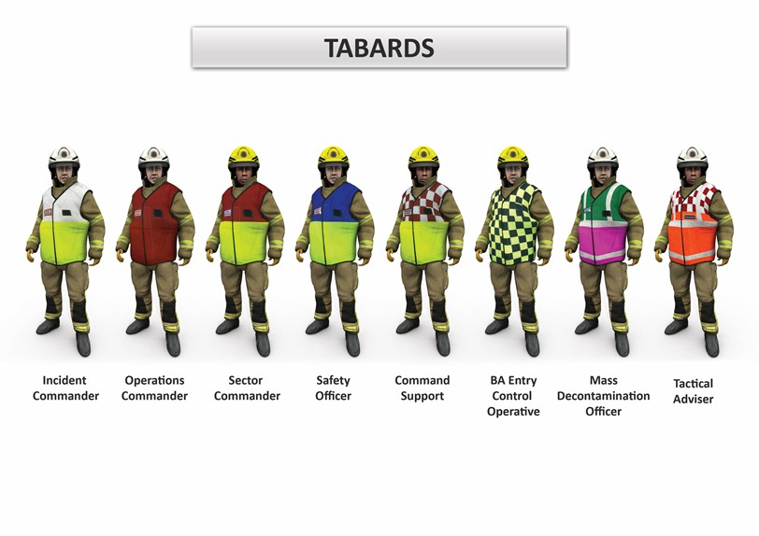

|  |
| --- |
| **SECTORISATION** |

**Sectorisation**

Operations often take place in more than one location during an incident for example, at the front and rear of a building. In such cases the incident commander's span of control may only be limited. Where an incident commander has the ability to monitor tasks by moving around the incident ground it is unlikely that sectors are needed. However, if the incident commander is unable to effectively manage operations and supervise safety at more than one location, then sectorisation should be considered.

Sectors should only be used when necessary and commanders should keep the structure as simple as possible. This is to reduce the possibility of barriers to information flow between crews and the incident commander.

Sectors should be introduced when the demands placed on an incident commander are high. In these cases, it is essential to delegate responsibility and authority. This ensures that the level of command and safety monitoring is appropriate for all activities.

The creation of sectors should only occur on the instruction of the incident commander to meet the demands of an incident. Except for exceptional circumstances, the use of sectors should follow the standard models.

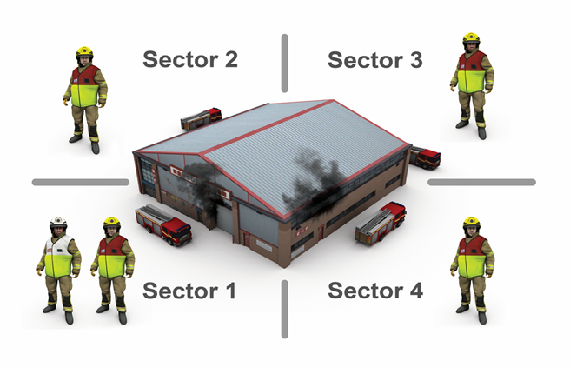

Using this approach, the front of a simple building is Sector One. Progressing in a clockwise direction, ‘Sector Three’ is normally at the rear. ‘Sector One’ could also be the main scene of operations if this is not the front. Where this is the case all personnel should be aware.

This will ensure consistency at major or cross border incidents where crews attend from two or more services. A plan showing demarcation of sectors at the command point can be useful for briefing purposes.

There may be some buildings or environments that do not suit the standard model. In these cases, it is important to designate the sectors carefully. There needs to be a good understanding of both the physical boundary and operating parameters and this needs to be communicated to avoid confusion.

## The difference between the Operational Sector Commander and the Support Sector Commander?

## The Operational Sector Commander will report to the Incident Commander or Operations Commander if in place.

## They will take responsibility for resources and the achievement of objectives within their sector. The sector commander will mainly focus on implementing the incident plan, effective command and control, resource deployment, firefighting tactics and rescues.

## The Support Sector Commander should report to the incident commander via the command support function. This is important to maintain spans of control. At more serious incidents, it is likely that the command support function will be led by a senior and experienced officer. Examples of support sectors are, Safety Sector, Water Sector.

**CLOSURE and HANDOVER**

Fire and Rescue Services are primarily involved at the emergency phase of an incident; however, they may be involved with associated protracted activities;

* Fire investigation
* Accident investigation (where a death has or may result then the Work-Related Deaths Protocol should be adhered to)
* Criminal investigation
* Fire safety issues
* Critical incident ongoing emotional and welfare support
* Incident debriefing and evaluation
* Learning and recommendations, both local and national
* Post-mortem enquiries and corners hearings
* Public or judicial inquiries
* Litigation

The incident commander should assess the need for post incident requirements as soon as possible. Based on their assessment the following tasks might be needed;

**Scene preservation** – if the scene needs to be examined as part of a criminal investigation.

**Recording and logging** – This may include a written log available from fire control, voice recordings of critical messages, photo’s / videos.

**Accident investigation** – If an accident or fault occurs, an investigation should be started. The incident commander should notify relevant personnel. Any fire service equipment should be preserved for investigation should the equipment have failed.

**Identification of key personnel** – The names and location of witnesses should be obtained and recorded for interviews. It may be necessary or appropriate to start interviewing during an incident.

**CORDONS**

The incident commander must consider the safety of firefighters, members of other agencies and the public. Cordons are an effective way of controlling resources and maintaining safety.

After the initial cordon has been established to secure the scene, normally by the police, the incident is usually divided into two distinct areas;

INNER CORDON

OUTER CRDON

The inner cordon controls access to the immediate scene of operations. The inner cordon denotes the hazard area.

The outer cordon limits access to an area being used by the emergency services and their relevant agencies. The police will usually control outer cordons, and may also use traffic cordons. The police will identify safe routes into and out of the cordon for emergency vehicles and other agencies.

|  |
| --- |
| **SAFETY MANAEMENT** |

**THE FIREFIGHTER SAFETY MAXIM**

There is a balance ensuring firefighter safety and carrying out the role of the fire and rescue service.

This is known as the Firefighter Safety Maxim and is as follows;

**“At every incident the greater the potential benefit of fire and rescue actions, the greater the risk that is accepted by commanders and firefighters. Activities that present a high risk to safety are limited to those that have the potential to save life or prevent rapid and significant escalation of the incident.”**

Operational personnel can remain as safe as possible if incident commanders:

* Identify hazards and risks
* Communicate the identified hazards and risks
* Adopt appropriate risk control measures
* Ensure people are using safe systems of work

**RISK CONCEPTS**

To perform an effective risk assessment, incident commanders should understand the definitions of Hazards, Risks and Control measures.

**HAZARD** – An event or situation with the potential to cause death or physical / psychological harm, damage / loss to property and / or disruption to the environment and / or economic, social and political structures.

**RISK** – The measure of significance of a potential harm in terms of its assessed likelihood and impact.

**CONTROL MEASURES** – These are measures to reduce the likelihood of exposure to a hazard from a given risk, and / or mitigate the impacts of that exposure.

A tool to help do a **DRA** is to use **E.R.I.C.**

**E**liminate, **R**educe, **I**solate, **C**ontrol

**Dynamic Risk Assessment** – DRA is the continuing assessment of risk in a rapidly changing environment at an incident. It is a process of quickly determining the nature of the risk and what the response should be. It confirms the response is appropriate by taking into account the benefit and risk. The assessment should determine reasonably practicable measures which should be taken t manage he risk.

**Analytical Risk Assessment** – Having carried out the dynamic risk assessment and established a tactical mode, an incident commander should be aware of the immediate hazards, who is at risk and control measures necessary to protect them. This assessment should determine the reasonably practicable measures that personnel should take to control the risk. This initial assessment now forms the basis of a more detailed incident risk assessment known as an analytical risk assessment (ARA). This should be completed and recorded on all occasions when the recorded dynamic risk assessment is not sufficient. The review of the ARA should be done whenever the risk to crews change. It is for each service to decide what a suitable interval is. The rule of thumb for an ARA, it should be done every 20 mins.

**Personal (or Individual) Risk Assessment** – There will be circumstances where firefighters may encounter unexpected or unforeseen situations. Personal or individual risk assessment is the process a firefighter undertakes to identify hazards and determine the level of risk they will accept. The outcomes of an individual risk assessment informs and influences their decisions.

Dynamic Risk Assessment (DRA) flowchart is a simple method to help fire and rescue personnel to make decisions regarding risk versus benefit. By following each step / process quickly all operational personnel can determine the nature of the risk and what the response should be.

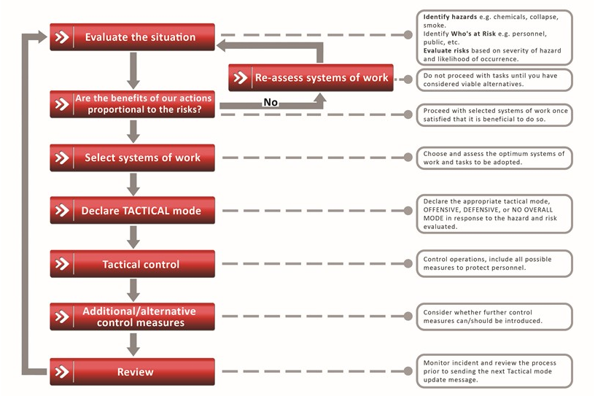

|  |
| --- |
| **TACTICAL MODES** |

**The Tactical Mode**

There are two modes of operation, **offensive** and **defensive**.

**Offensive**

Crews are working within the designated hazard area and thereby, exposed to greater risk.

**Defensive**

Crews are outside of the designated hazard area.

**Hazard areas**

The hazard area is an area in which significant hazards have been identified by the relevant commanders. The hazard area may extend beyond the immediate scene of operations and in some cases can move or change during the incident.

**Offensive mode**

This is where fire service personnel are working within the hazard area and exposed to greater risk, because the incident commander has decided it is appropriate following their risk assessment.

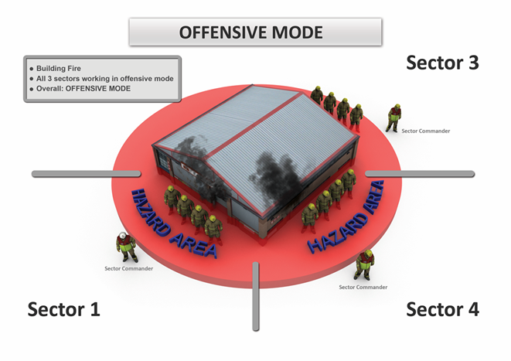

This mode may apply to an individual sector or to the whole incident when every sector is offensive.

Offensive mode is likely to be the common mode of operation. Examples include house fires, road traffic collisions and industrial premises where we might fight the fire, effect rescues or close down the plant.

Examples of offensive mode:

* A property fire where crews enter the building for firefighting
* Crews dealing with an incident outside a building but still operating in the hazard area
* Crews dealing with a road traffic collision and working on the carriageway
* Withdrawing a crew from a hazardous area because the risk has increased

In the last example, although crews are being withdrawn, they are still in the hazard area and the tactical mode is still offensive. It would not change to defensive mode until all crews have left the hazard area and been accounted for. Use the message "tactical withdrawal in progress" or "emergency evacuation in progress" to time stamp the decision of the incident commander's dynamic risk assessment, including the need to change to defensive mode.

**Defensive mode**

This is where commanders deal with an incident from a defensive position. In defensive mode, the identified risks are unacceptable and outweigh the potential benefits. No matter how many extra control measures could put in place at that particular time, the risks are remain too great to commit crews into the hazard area

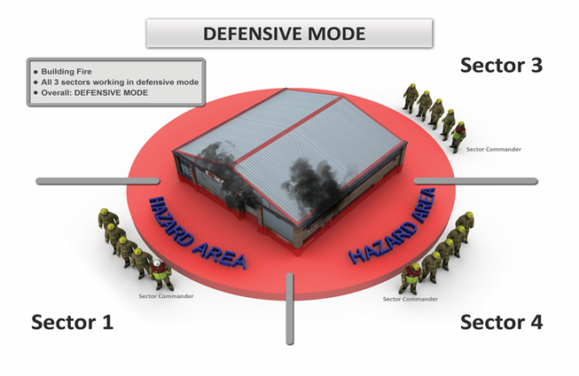

Defensive mode indicates that no crews are working in the hazard area. It does not indicate the no operational activity is taking place.

Examples of defensive mode:

* Firefighting outside a hazard area
* Standing by awaiting expert advice, before committing crews
* Standing by, in a safe area while other services deal with an incident, for example, a terrorist related incident

There will be circumstances, where having been in defensive mode, the risk has changed, tactical priorities have been revised or additional control measures are available. This may mean it is acceptable to enter or re-enter the hazard area. In this case as crews are committed the tactical mode will change to offensive.

**Using tactical mode when sectors are in use**

When the incident has been divided into sectors, the Incident Commander remains responsible for the tactical mode at all times. There will be occasions when an operations commander has been appointed. Whilst they may determine or approve a change in tactical mode, the Incident Commander still retains overall responsibility.

Where more than one sector is in use:

* Where each sector is in offensive mode then the overall mode of the incident is offensive.
* Where each sector is in defensive mode then the overall mode of the incident will be defensive.
* Where different modes are in use at the same incident, there is no overall mode for the incident. For example, when two sectors in offensive mode and one sector in defensive mode. All messages to fire control room or across the incident ground should list each sector and the mode it is in. for example, "Sector one defensive mode, Sector three defensive mode, Sector four offensive mode."

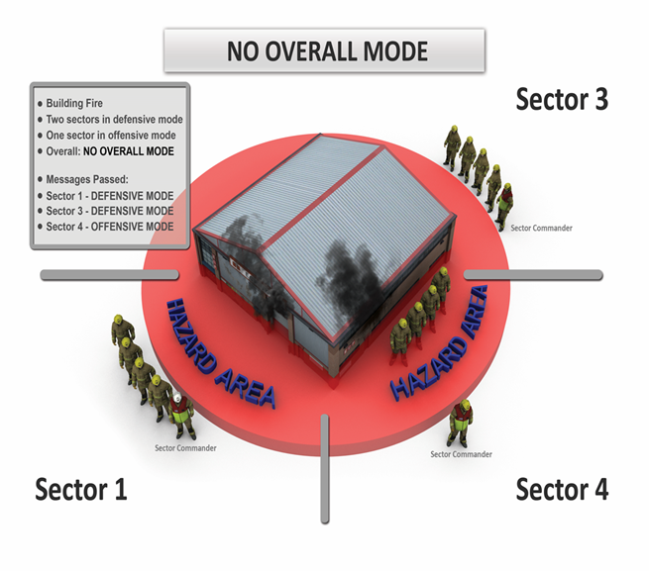

Where appropriate, Incident Commanders should confer with Sector Commanders when making a decision to change the tactical mode. It is more usual for the suggestion to change tactical mode to come from a sector commander.

If a Sector Commander wishes to commit personnel into the hazard area, for example, change to offensive mode when the prevailing mode is defensive, they should seek permission from the Incident or Operations Commander. They should not make any change until they have received permission.

Where a rapid change in circumstances occurs, the Sector Commander should revise the risk assessment. There may be occasions when they need to act first in the interests of safety and then inform the Incident Commander of their decision.

**Announcement of tactical mode**

Commanders should make sure everyone on the incident ground is aware of the tactical mode. They should communicate this at regular intervals and when it changes. It is also essential that fire control is informed of the current mode to ensure it is recorded. All messages should include sufficient information regarding the findings of the risk assessment. It is for individual services to decide the frequency of announcements.

The radio message to fire control may also be the method of recording significant findings from a risk assessment. If this is the case it should include sufficient information about why the mode is appropriate.

For example:

•'Crews in offensive mode: persons reported or saveable life'

•'Crews in offensive mode: saveable property'

•'Crews in offensive mode: environmental protection'

•'Crews in defensive mode: awaiting isolation of power cables'

All incidents need a tactical mode and it should be kept current.

**Change in tactical mode**

There will be occasions when it is necessary to change the tactical mode, following the revision and updating of the risk assessment. This change may be on receipt of new information, a change in tactical priorities or a revision of control measures.

Where the decision is made to commit crews into the hazard area and when defensive operations are in place, the tactical mode for the incident or sector will change to offensive mode as preparations are being made to enter the hazard area.

When it is necessary to change from offensive mode to defensive mode, following the outcome of the risk assessment, the commander should announce and implement the withdrawal of crews or personnel from the hazard area. The use of **'tactical withdrawal'** or **'emergency evacuation'** should be included in communicating the change in mode to the incident ground and fire control. The tactical mode does not change until fire and rescue service personnel have withdrawn from the hazard area.

There are a number of reasons why the change to defensive does not take place until after fire and rescue service personnel have left the hazard area. This is because personnel will still be in the hazard area and it may take some time to withdraw, for example, at high rise and large or complex structures. There may also be a need to commit crews to assist with the tactical withdrawal or emergency evacuation, to relay messages, protect escape routes or effect rescues of colleagues.

The terms 'tactical withdrawal' or 'emergency evacuation' should be used within the message to fire control to time-stamp the decision of the incident commander's dynamic risk assessment. Radio messages should be timely, without detracting from risk critical operations, and include sufficient information demonstrating the need to change to defensive mode, for example:

•'Offensive mode: all persons accounted for, tactical withdrawal in progress'…. followed by;

•'Defensive mode: all crews withdrawn'

•'Offensive mode – emergency evacuation, signs of structural collapse' … followed by;

•'Offensive mode – emergency evacuation in progress, crews committed to assist in evacuation'…followed by;

•'Defensive mode – all personnel accounted for, roll call complete'

At certain incidents, other responders may continue to work in the hazard area, for example at a CBRN (E) incident.

**EMERGENCY EVACUATION and TACTICAL WITHDRAWAL**

The incident command system provides two formal means of withdrawing personnel from the scene of operations:

An emergency evacuation and a tactical withdrawal.

Contingency plans an incident commander makes should help to evacuate people at highest risk while protecting escape routes. Also, removing people from areas where the risk has become too high.

**Emergency evacuation**

The incident commander should inform all personnel at an incident of the location of the muster point. At a prolonged incident the location of the muster point may change. They should ensure that all personnel know about any change.

The standard evacuation signal within the fire and rescue service is repeated short blasts on an Acme Thunder type whistle. On hearing this signal all other personnel with whistles should also give the warning to amplify its importance and ensure all personnel are aware across the whole incident. This signal tells everyone that they need to evacuate the incident ground.

**Tactical Withdrawal**

The incident commander may need to redeploy resources or move people away from danger. This is a tactical withdrawal. When a tactical withdrawal has taken place there will not be an evacuation signal or a full incident roll call.

As crews will still be in the hazard area then the tactical mode will remain offensive. To timestamp the dynamic risk assessment that crews should be withdrawn, an informative message should be sent using the phrase “tactical withdrawal in progress”

This element can be demonstrated by practical exercises using the incident command system and observation assessment.